Formula Sheet

Kenny Vo

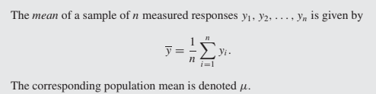

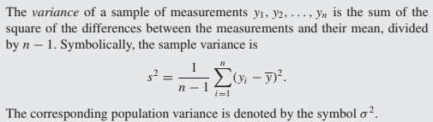

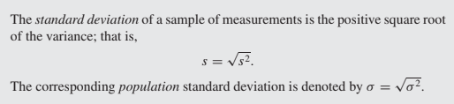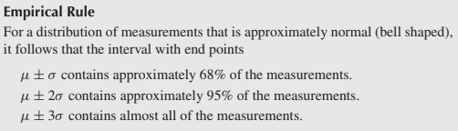

Permutation: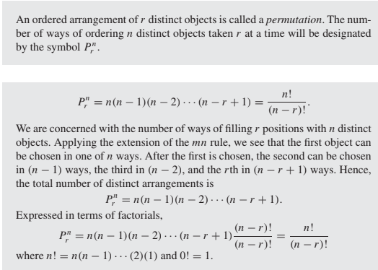

n distant objects into k distinct groups:

Combination of n objects taken r at a time: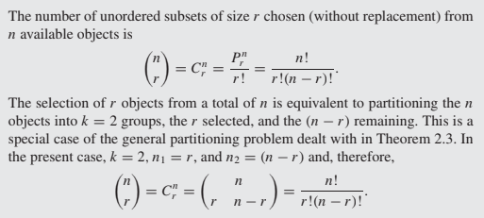

Conditional of event A given that an event B has occurred: 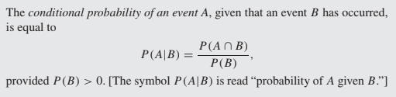

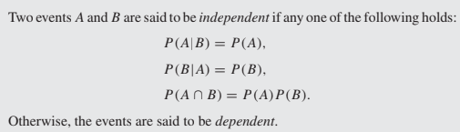

The multiplication rule of probability: P(A and B) = P(A) \* P(B|A) : 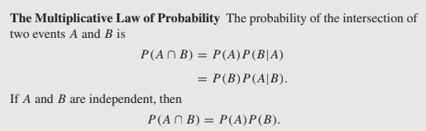

The addition rule of probability: P(A or B) = P(A) + P(B) - P(A and B): 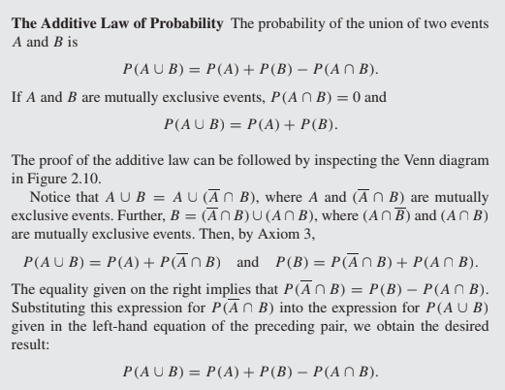

Bayes' rule: P(A|B) = P(B|A) \* P(A) / P(B) : 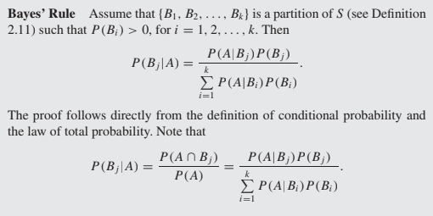

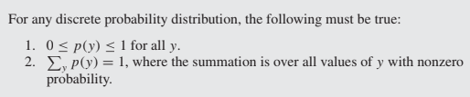

Expected value of a random variable or a function of a random variable : 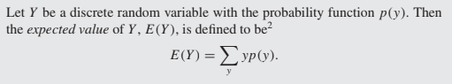

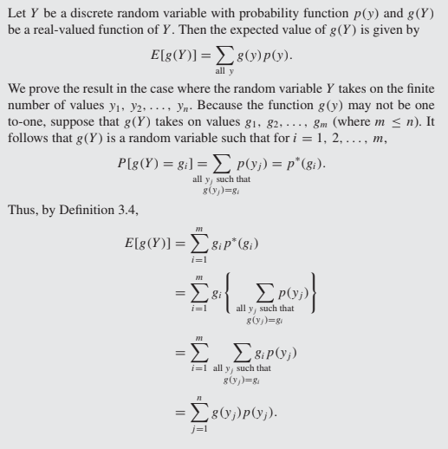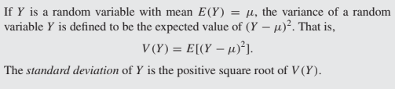

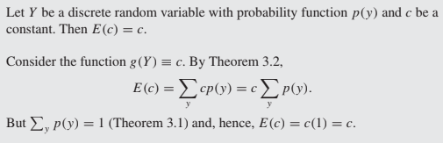

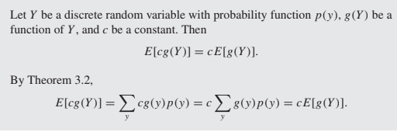

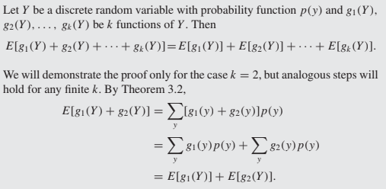

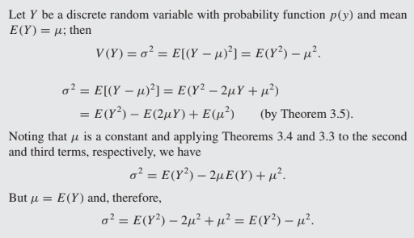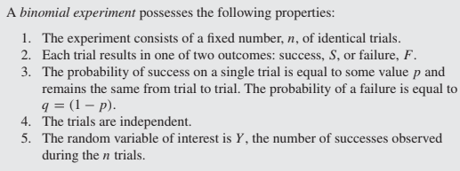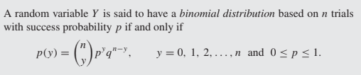

Binomial random variable based on n trails and success probability p : 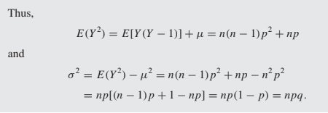

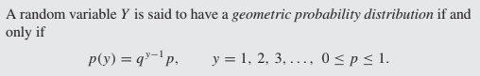

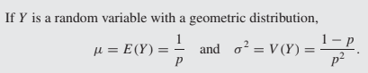

Geometric distribution with a probability of success p:

A success occurs on or before nth trail:

P(X<=n)=1-(1-p)^n

A success occurs before nth trail:

P(X<n)=1-(1-p)^(n-1)

A success occurs on or after nth trail:

P(X>=n)=(1-p)^(n-1)

A success occurs after nth trail:

P(X>n)=(1-p)^n